**MYOB Pay Slip Application**

About MYOB Pay Slip Application:

MYOB application generates pay slip based on various calculations and inputs about employee.

Software Requirements:

Visual Studio 2015 is required to run this solution.

Instructions to Run Application:

1. Run Visual Studio 2015
2. Build the solution.
3. Set MYOB_PaySlip.Web as startup project by right clicking on project and selecting option from context menu to “Set as StartUp Project”.

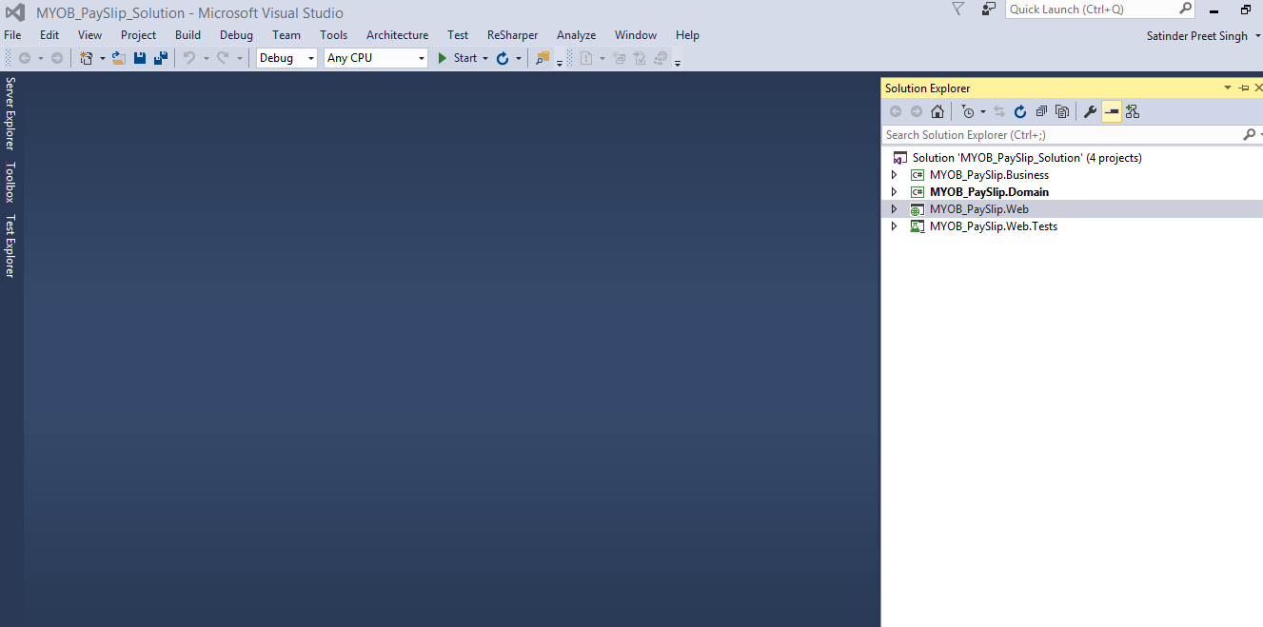

1. Run the project using Debug option from top menu.

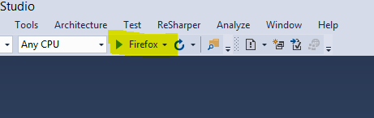

1. Navigate to [http://localhost:{xxxxx}/PaySlip/GeneratePaySlip](http://localhost:%7bxxxxx%7d/PaySlip/GeneratePaySlip)
2. Enter values in following shown form and click on Generate Pay Slip.

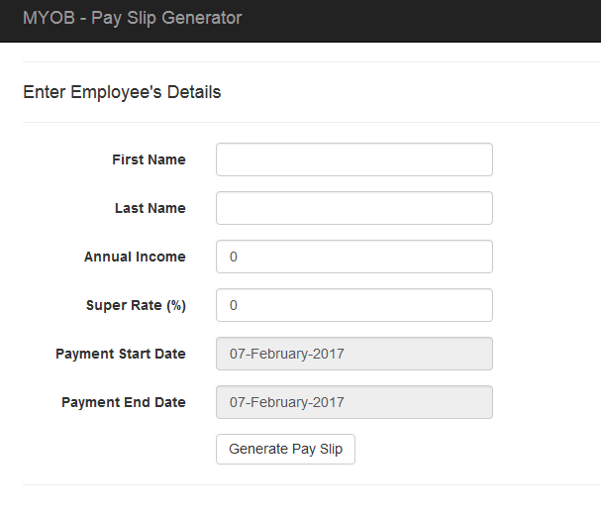

1. It will show result payslip:

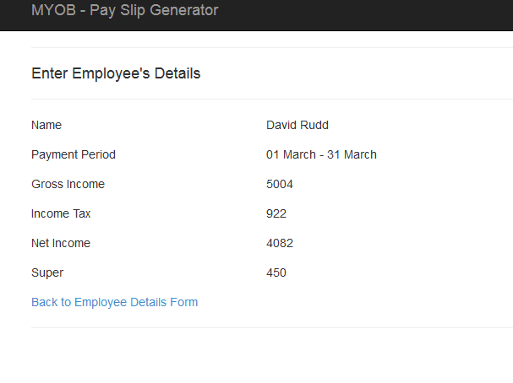

Assumption:

1. All fields were considered as required.
2. Since it was not mentioned and also was not in scope of application about payslip format. This application will result into object which can be further used in any type of output.